**Write a CPU bound C program and a I/O bound C program and observe the effect of their CPU share using the top command and its variants.**

**CPU Bound**

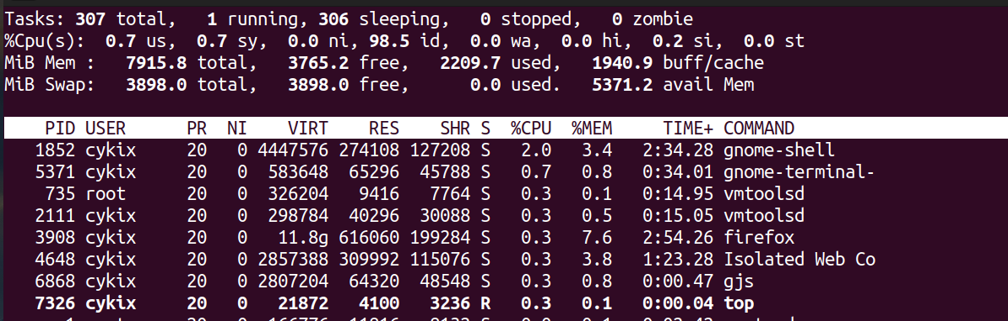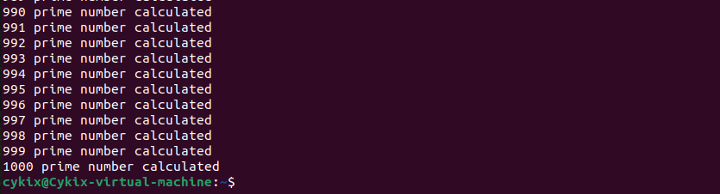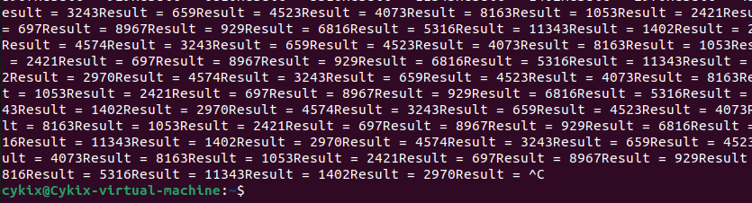

**I/O Bound**

